TECHNICAL PROJECT REPORT

# Title of Invention / Project: LPG GAS LEAK DETECTOR

# Team Members / Inventors:

|  |  |  |  |  |  |
| --- | --- | --- | --- | --- | --- |
| **S. No.** | **Name** | **Department** | **Designation** | **Mobile** | **E-Mail** |
| 1. | Dinesh | CSE | Leader | 8008339781 | [dineshpotla357@gmail.com](mailto:dineshpotla357@gmail.com) |
| 2. | Nune Vasudev | CSE | Member | 9494111102 | [nunevasudev7@gmail.com](mailto:nunevasudev7@gmail.com) |
| 3. | Martha Phanindra | CSE | Member | 9704931880 | [himeshphanindra@gmail.com](mailto:himeshphanindra@gmail.com) |
| 4. |  |  |  |  |  |
| 5. | Khushal Thakur | ECE | Mentor | 9646030764 | khushal.thakur@cumail.in |
| 6. | Anshul Sharma | ECE | Mentor | 9478697475 | anshulsharma.ece@cumail.in |
| 7. | Kiran Jot Singh | ECE | Mentor | 9463909689 | kiranjotsingh.ece@cumal.in |
| 8. | Divneet Singh Kapoor | ECE | Mentor | 9878422653 | divneet.ece@cumail.in |

Section – 1 (IPR Related)

# Brief Abstract (500 words):

* Problem your project is solving?

-LPG gas detector important this helps prevent accident occurred because of fire.

-It also useful in protecting human life , wealth and property

* How are you solving that (solution)?

-We are solving Gas accidents by a simple gas detecting and makes alarm

-MQ-6 sensor is used which detects the gas and makes alarm

- when LPG gas is leaked then MQ-6 sensor automatically makes buzzer to make sound

* Additional modifications that can cater to improved solution?

MQ-6 module is used which doesn’t require Arduino so that cost of making will become less and also in simple manner

# Existing state-of-the-art and Drawbacks in existing state-of-the-art

|  |  |  |
| --- | --- | --- |
| **S. No.** | **Existing state of art** | **Drawbacks in existing state of art** |
| 1 | 12v lpg gas alarm | Takes more power |
| 2 | HPL gas detector | Cost is more |

# Novel/Additional modifications that you can propose to improve upon drawbacks

* We can monitor more parameters like GSM or SMS base LPG leakage detection system.

# Advantages

1) This project can be used in home and hotel utility(kitchen) area for safety purpose

2) useful in domestic LPG water heater

3) very useful in LPG/CNG fitted car to avoid measure accident .

4) Prevent measure accident in gas agencies (gas station) where multi cylinder stored.

# Block Diagram

BUZZER

SENSOR

BATTERY

Section – 2 (Real Project)

# Materials

LPG gas sensor x1 – detects the LPG gas

Battery – 1 – gives power to the circuit

Wires – 5 – to connect circuit

Buzzer – 1 – to get alarm output

# Circuit Diagram

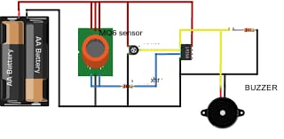

# Steps of Circuit Completion

1. Take MQ-6 Sensor and connect with Wires to VCC,GND,ADUT. 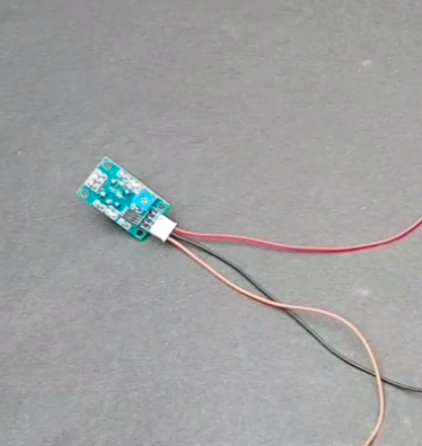
2. Wire from VCC from sensor will connected to positive terminal of buzzer.
3. DOUT from sensor will connected to Negative terminal of buzzer.
4. Both wires junction of positive terminal of buzzer and VCC will connected to +VE of battery 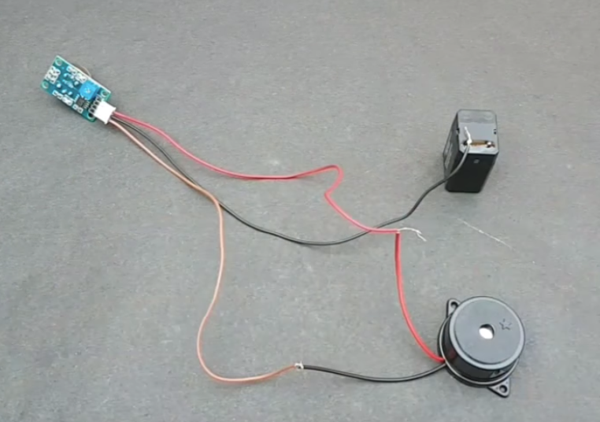
5. Project will be placed in finely created structure of cardboard
6. Project is ready to use

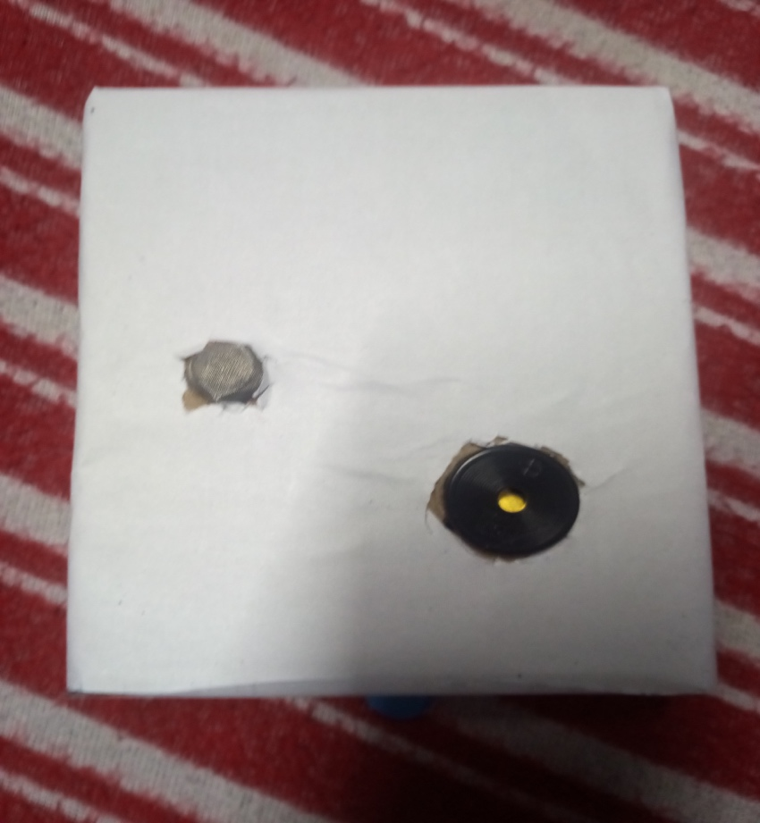

# Program Code

https://github.com/dineshpotla/beee